Plot of Residuals vs Fitted Data

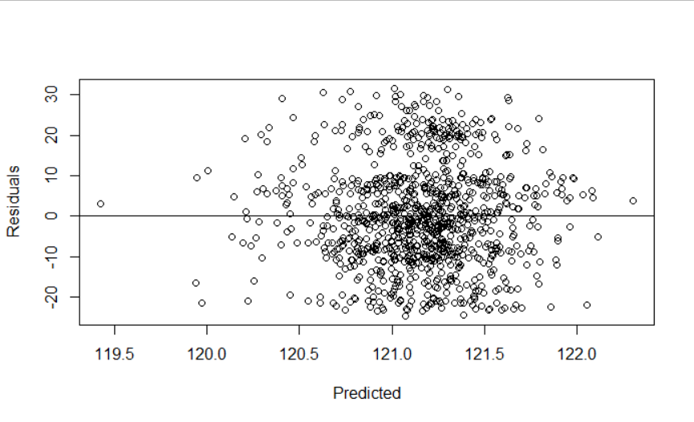

Plot of Residuals vs Oil

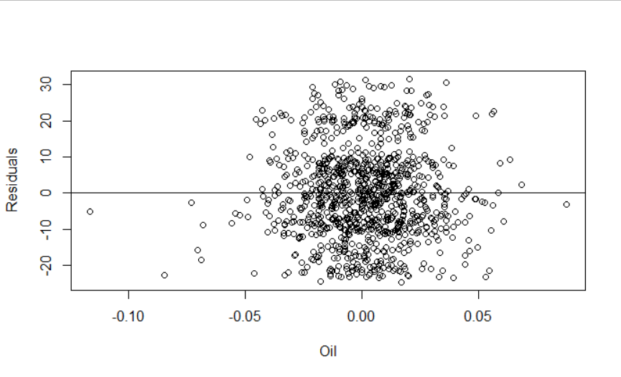

Plot of Residuals vs Gold

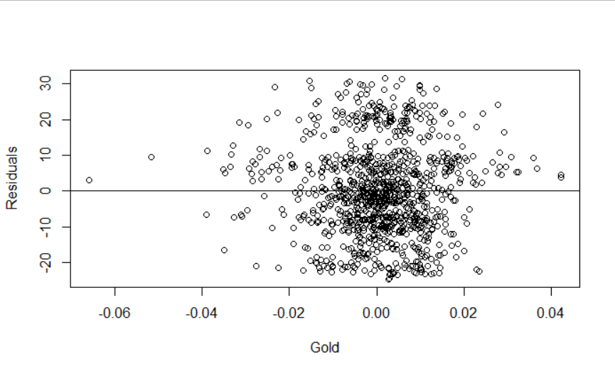Plot of Residuals vs Row Number

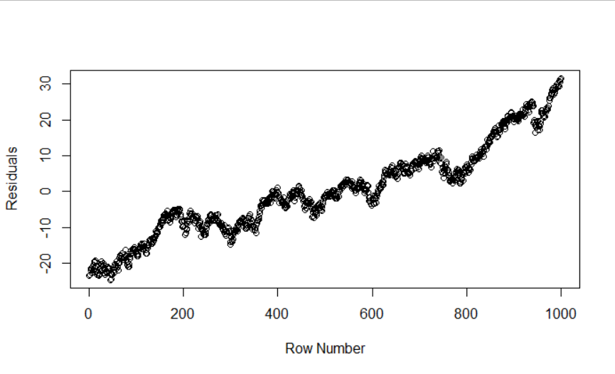

Normal Quantile Plot

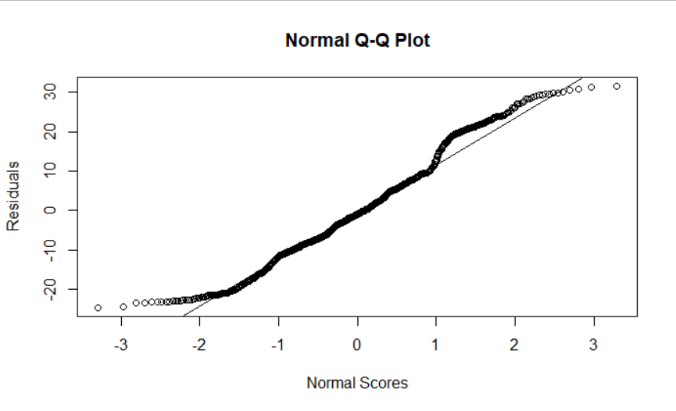

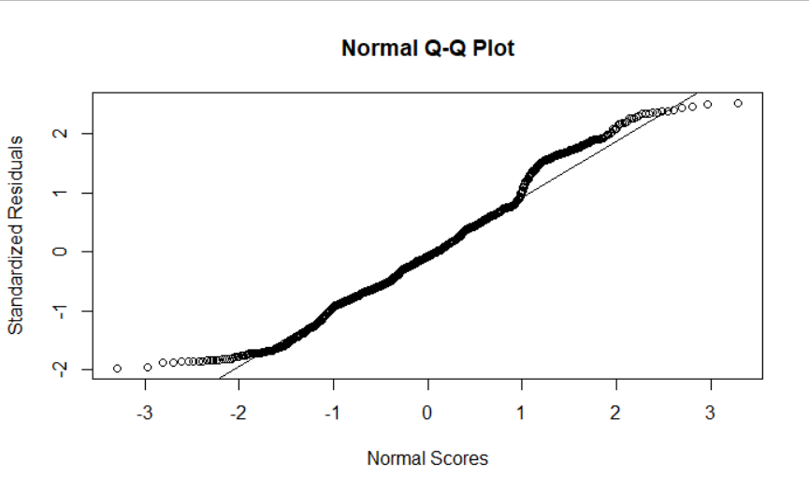

 An S-shaped pattern of deviations indicates that the residuals have excessive *kurtosis*